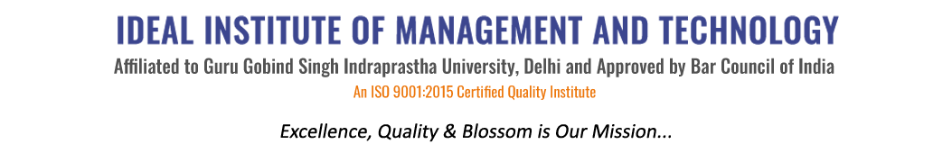
16 X, Karkardooma Institutional Area, (Near Telephone Exchange)
Delhi-110092
+91 (11) 22372639, 22375961,
http://idealinstitute.edu.in
MOTHER DAIRY (16-11-15)
BBA (GEN) 2nd Shift

S.No. | Name | Enrollment No.
1 | Shubham Gupta | 00121001714
2 | Himani | 00221001714
3 | Anshul Pal | 00321001714
4 | Mohd Aqib | 00421001714
5 | Shilpi Jain | 00521001714
6 | Sanjay Singh Bisht | 00621001714
7 | Deepakshi Upadhyay | 00721001714
8 | Gourish Kalra | 00821001714
9 | Aman Sharma | 01021001714
10 | Nitin Narang | 01121001714
11 | Puneet Kumar Lunawat | 01221001714
12 | Shivay Allawadhi | 01321001714
13 | M Sharon Roseleena | 01421001714
14 | Arpit Gupta | 01521001714
15 | Shubham Goyal | 01621001714
16 | Abhishek Verma | 01721001714
17 | Hardick Batra | 01821001714
18 | Muskan Bhatt | 01921001714
19 | Kashish Arora | 02021001714
20 | Himanshi Kukreja | 02121001714
21 | Abhishek | 02321001714
22 | Amrit Pal Singh | 02421001714
23 | Kush Dhamija | 02521001714
24 | Ankur Goel | 02821001714
25 | Ayush Mahajan | 02921001714
26 | Puneet Gulati | 03021001714
27 | Ravi Karnani | 03221001714
28 | Aakash Bhardwaj | 03321001714
29 | Prateek Tiwari | 03421001714
30 | Samradh Chandra | 03521001714
31 | Priyanka Ahuja | 03621001714
32 | Ashish Malik
33 | Sahil kumar
34 | Piyush
35 | Abhhay kumar

